Casey Gray
ITEC 4365
February 4, 2025
Assignment 2

- Show your folder and subfolder.
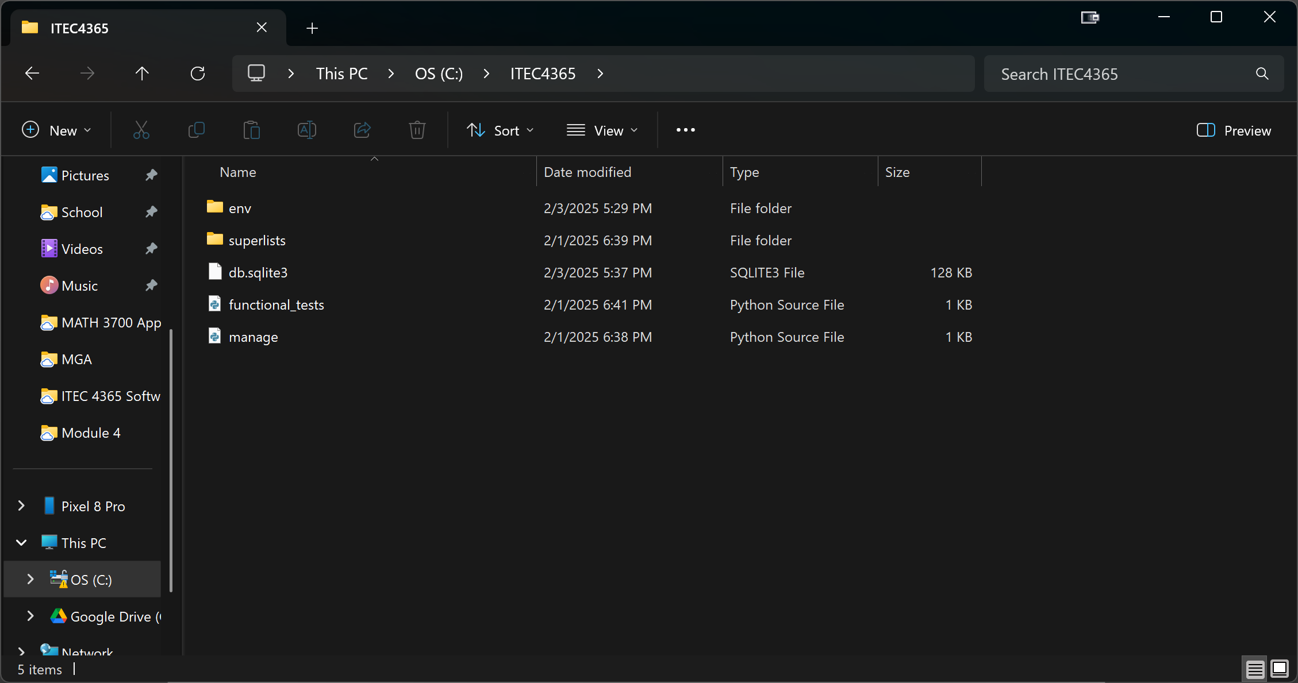
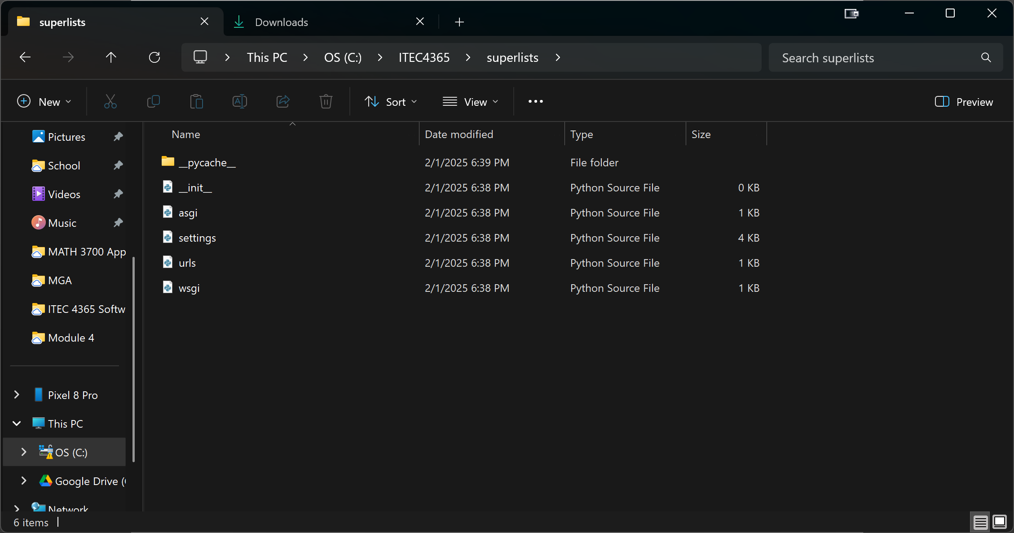
2. Show your results on the development server at http://127.0.0.1:8000/
